Jennifer Daniel

CIT480

Chapter 14 Exercises

**Exercise 14-1:**

Part 1/2:

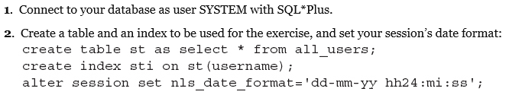

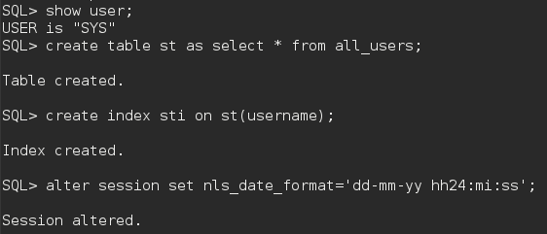

Part 3:



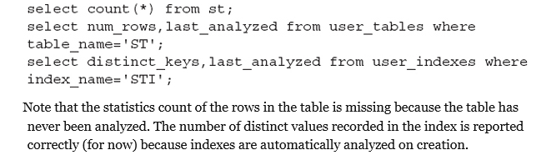

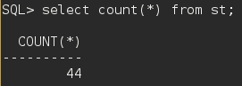

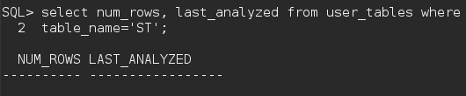

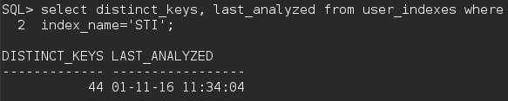

Part 4:



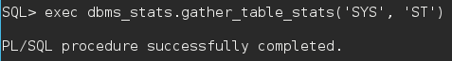

Part 5:

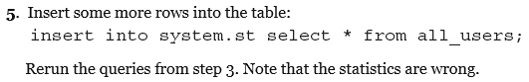

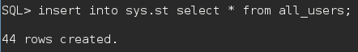

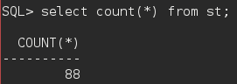

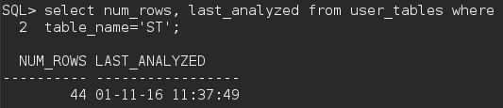

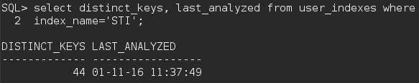

Part 6:

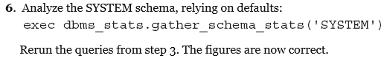



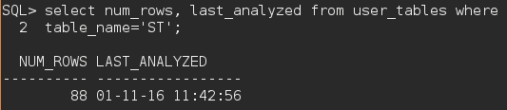

Part 7:



**Exercise 14-2:**

Part 1/2:

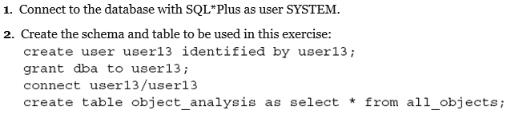

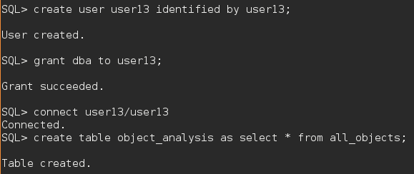

Part 3:

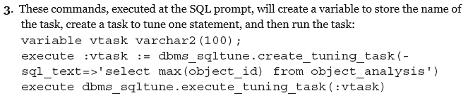

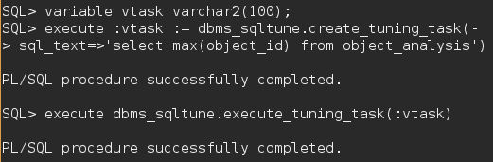

Part 4:

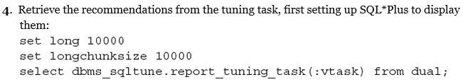

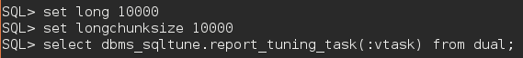

Part 5:

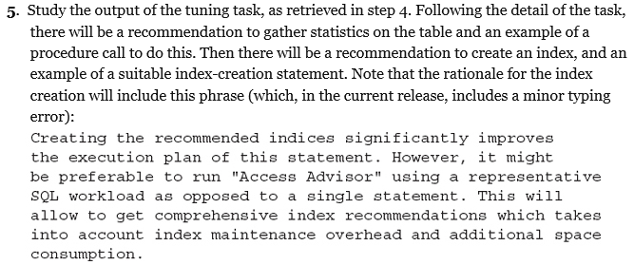

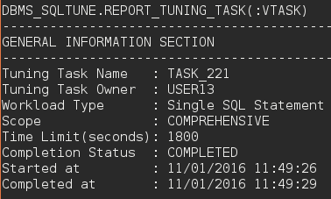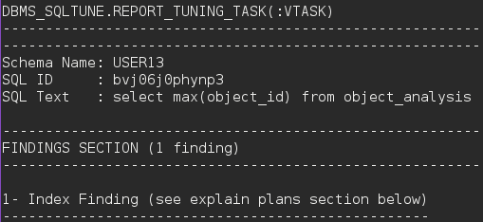

Part 6:

